AI Use Declaration Form
Course: Introduction to Artificial Intelligence
Lab Title: Lab 2
Student Name: Chrishelle Wiafe
Student ID: 85942028
GitHub Repository Link:
Date Submitted: 03/07/26

1. AI Use Summary
Question | Student Response
Did you use any AI tool for this lab? | Yes please
Estimated percentage of the work influenced by AI | 24%
Did you attach evidence of AI use where applicable? | yes

2. Details of AI Use
Complete the table below for each AI tool used. Add more rows where necessary.
Name of AI Tool Used | Purpose for Using the Tool | Prompt or Instruction Given to the Tool | Part(s) of the Work Influenced by the Tool | How I Verified, Edited, or Improved the AI Output
ChatGPT | Understanding and implementing concepts | i need your help in learning machine learning through this lab. You will analyse each section and part, and teach me step-by-step how to approach. Let the understanding be easy so i can answer the student reasoning questions after properly. The datasets have also been attached for more information | Training the regressor, Test splitting
ChatGpt | Clarification on instructions | Okay, so I need your help in following some steps in configuring my VS Code for a particular lab work. So I'll send you the prompts and you help me to do the instructions.By the end of this lab, you will be able to:  Set up a professional Python development environment using VS Code or Cursor  Create and manage Python virtual environments with venv or Conda  Perform basic Git operations (clone, commit, push) on GitHub  Launch and configure Google Colab notebooks with GPU acceleration  Manipulate multi-dimensional arrays using NumPy broadcasting  Load, clean, and transform data using Pandas  Create informative visualizations with Matplotlib and Seaborn. so rn i have aready created my virtual environment, so lets stsart withe ither creating a git hub repository and connecting it | Github setup | Overlooked ai results with github resources
ChatGpt | Correction of errors | this is my code; explain the error in the last but second line; from sklearn.model_selection import train_test_split from sklearn.preprocessing import StandardScaler # TODO: Separate features (X) and target (y = tip_amount) x = taxi.drop(columns=['tip_amount']) y = taxi['tip_amount'] … | Section 1

3. Attachment of AI Output Evidence
Where required, attach evidence of AI use. Tick all that apply. Add more rows where necessary.
Evidence Type | Attached? (Yes, No, N/A) | File Name
AI-generated draft | yes | 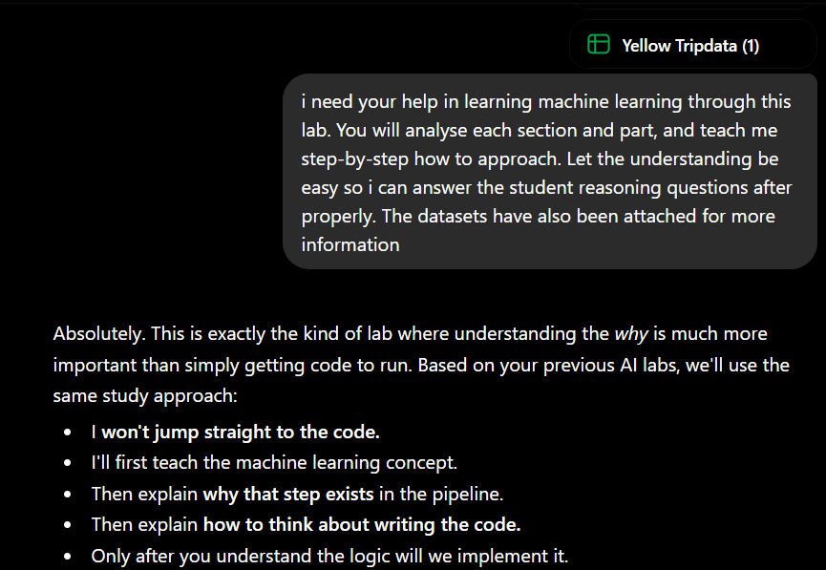
Prompt history
Screenshot of AI interaction | yes | 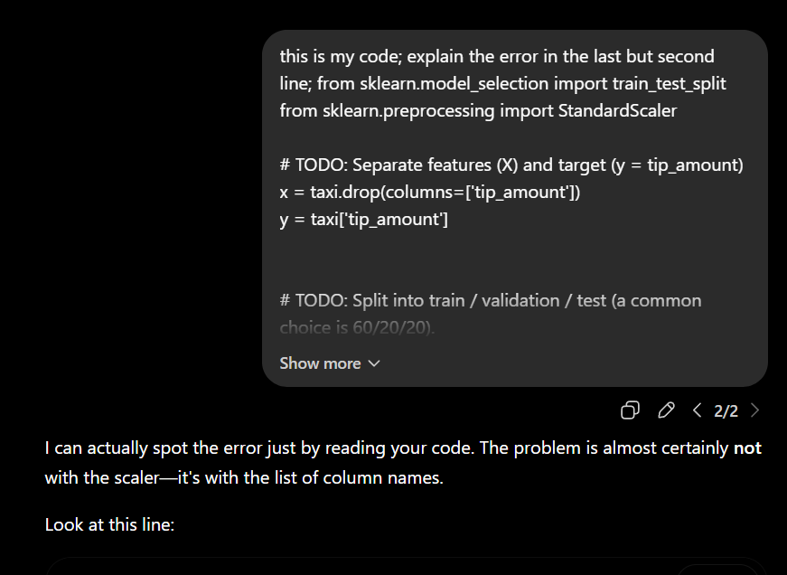
Exported AI conversation
AI-generated code snippet |  | 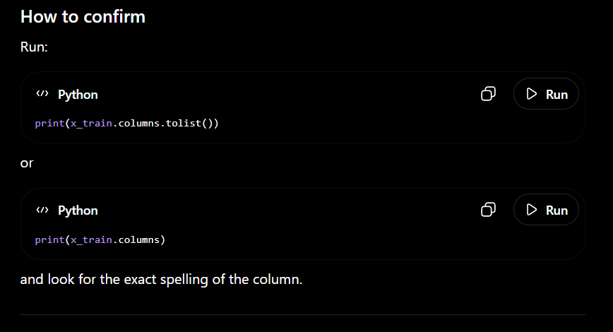
Revised version showing student input

4. Student Declaration
I declare that:
Declaration Statement | Response (Yes/No)
The submitted work is my own work. | yes
Any use of AI tools has been clearly declared in this form. | yes
The prompts, instructions, and AI-generated outputs have been disclosed where applicable. | yes
I reviewed, tested, edited, and improved any AI-generated content before submission. | yes
My AI usage does not exceed 25% of the entire work. | yes
I understand that undeclared or excessive AI use may be treated as academic misconduct. | no

Student Signature: C.W
Date: 03/07/2026

